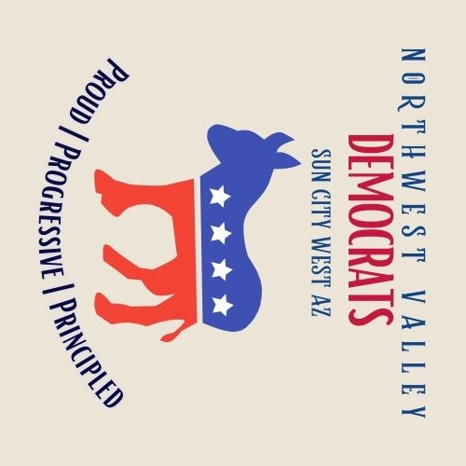**MEMBERSHIP FORM**

Date of Membership Application _____________

New □ Renewal □

Does the information below include changes from the previous year? Yes □ No □

If “Yes,” please provide updated information below.

Member #1 _________________________________________________

Member #2 __________________________________________________

Local Address ________________________________________________

___________________________________________________________

Best Phone # ____________________________ Cell □ Landline □

Best Phone # (Mem #2) ________________________ Cell □ Landline □

Email Address: ______________________________________________

***Optional*** Email for Member #2 (if different): ___________________________

|  |
| --- |
| **FOR ADMINISTRATIVE PURPOSES ONLY** Date Received __________________  Check # _____________ or amount of cash received $________ State __________  Excel __________ |

Annual dues are $15 PER PERSON for membership period, January 1 to Dec 31st. Please make checks out to Northwest Valley Democrats. You may pay your dues at any meeting or mail your check to:

**Northwest Valley Democrats**

**P.O. Box 5456**

**Sun City West, AZ 85375**